**Assignment 11**

1. Create a module called validate.py which has the following functions to:

* Create and return an OTP of 4 digits using the functions from random module.
* Create and return a Captcha of length as per requirement – comprising a digit, an uppercase letter, a lowercase letter and a special character.
  + Default length = 4 (one of each).
  + Handle the case when the user enters a length less than 4.
  + If the user enters length > 4, then you can choose to repeat any of the 4(digit / uppercase / lowercase/ spl.char) at random to satisfy the required length. Make sure one of each is definitely part of the Captcha.

Include this module in your program and based on a menu call the respective functions.

1. Use the tkinter library to create a window in the following manner:

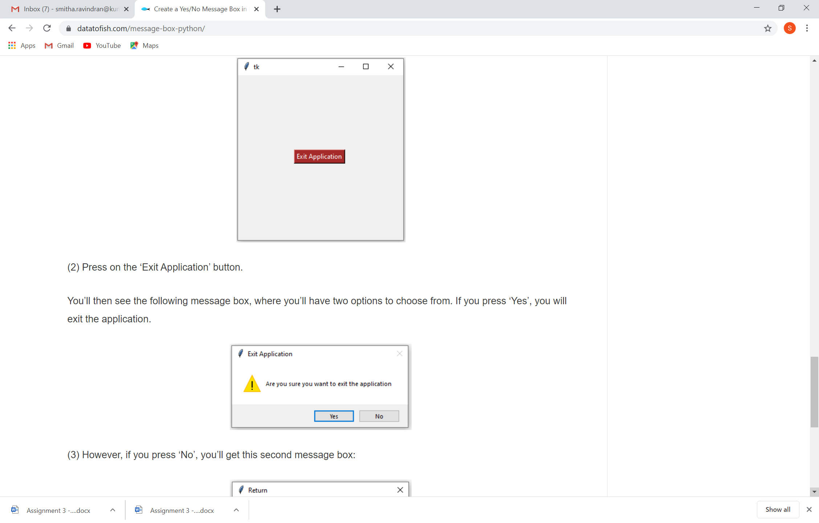

On pressing exit application the user should get a message such as:

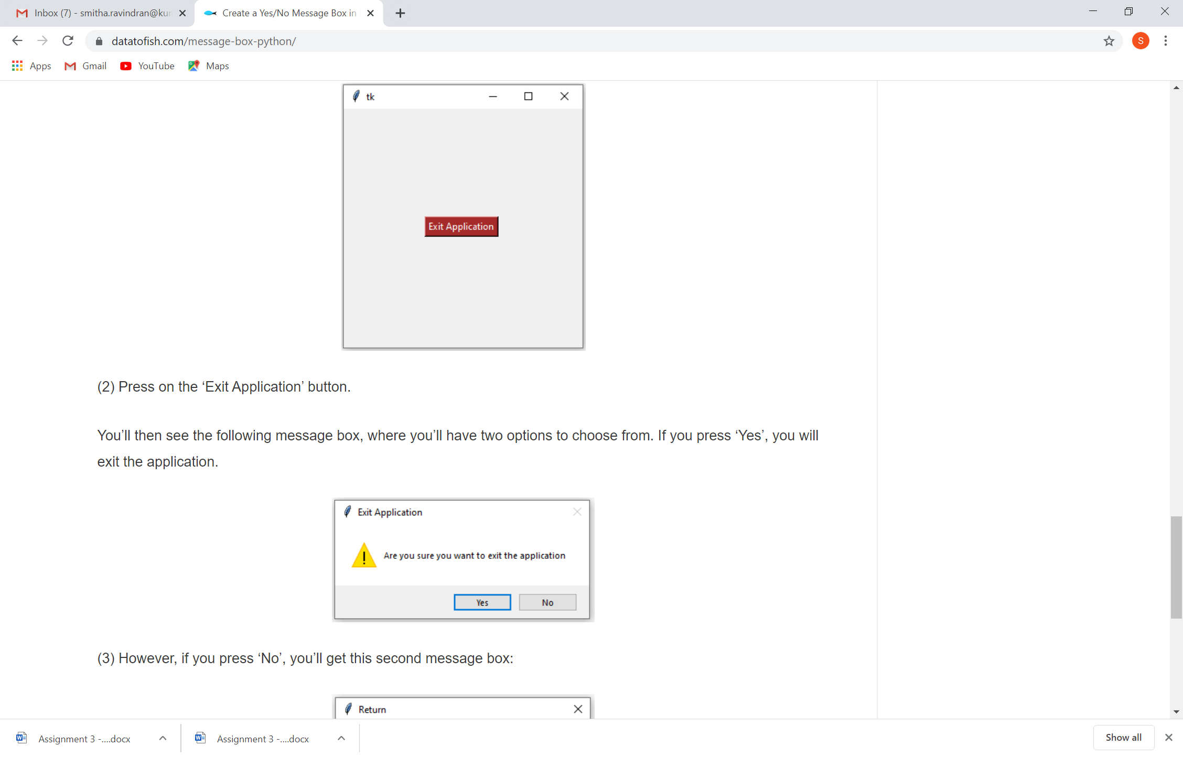

If yes , exit otherwise keep the screen.

1. Taking the current time in India calculate the time in
   1. New York (9 hours 30 minutes behind Calcutta)
   2. Sydney(5 hours 30 minutes ahead of Calcutta)
   3. Johannesburg ( 3 hours 30 minutes behind Calcutta)

Display the time in 24 hours format.

(Use necessary libraries)